Directory Management System Project

Phase I Part 1
Use Astah to draw a class diagram diagram. Use proper UML notation. Take a clear screenshot of your completed diagram and paste it on this page.

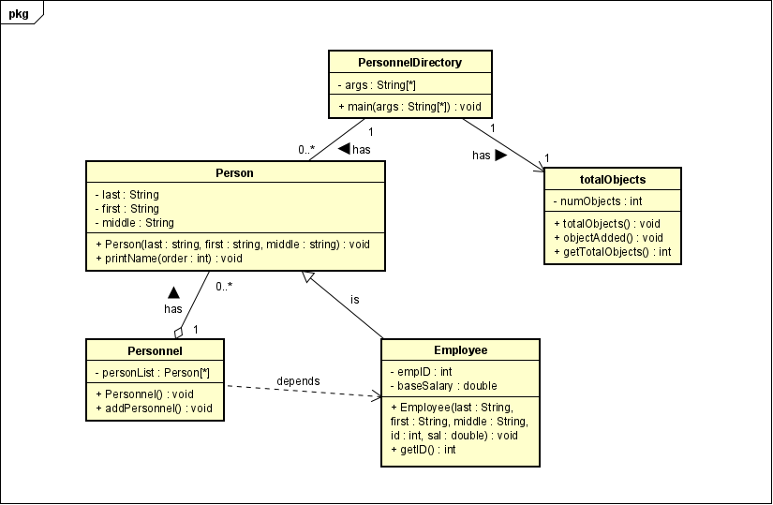

Phase I Part 2
Identify the places in the code where there are object-oriented concept violations, content coupling, common coupling, control coupling, and stamp coupling situations. On this page, paste the code segments that correspond to each situation and explain how you would fix object-oriented concept violations, common coupling, control coupling, and content coupling issues. You may add pages if necessary.

public class Person {
public String last;
public String first;
public String middle;
…
}

The code violates the object-oriented concept of encapsulation, where the class should be declared as private. I would change the visibility of the attributes from public to private. We should also add getter methods for the first, mid, and last name to allow for controlled access to these fields.

public void printName(int order)
{
if(order == 0)
{
System.out.println(first + " " + middle + " " + last);
}else if(order == 1)
{
System.out.println(first + " ," + last+ " " + middle);
}
else if(order == 2)
{
System.out.println(last + " ," + first + " " + middle);
}
}

The code violates control coupling, and I would fix this by “big” function into “smaller” functions or method. I would make 3 methods where 1 prints in order of firstmidlast, 1 in order of firstlastmid, and 1 in order lastfirstmid but all separate instead of together like the given code.

public class Employee extends Person{
private int empID;
private double baseSalary;
…
empID = id;
baseSalary = sal;
…
}

The code violates encapsulation. In this part of the Employee file, we see that the empID and baseSalary attributes are set up for encapsulation, but we use empID =idl; instead of using “this” variable to call the empID variable for us. Later in the code, we are also missing the method to get our baseSalary.

public class Personnel {
public ArrayList<Person> personList;
…
}

The code violates encapsulation and content coupling. The personList should be declared as private for encapsulation and to prevent modification from outside classes to allow for safe interaction between your personList and Personnel classes.

public class TotalObjects {
private static int numObjects = 0;
…
}

The code in totalObjects.java violates common coupling because of the use of the static variable and I would fix this issue by changing it to just a private instance variable to avoid having other classes from interfering with our numObjects variable.

do{

System.out.println("Welcome to the Personnel Directory Management System");
System.out.println("====================================================");

System.out.println("\n\n\t 1. Add Personel");
System.out.println("\n\t 2. Find Personel");
System.out.println("\n\t 3. Print Names");
System.out.println("\n\t 4. Number of Entries in the Directory");

System.out.println("\n\t Select one of the options above (1, 2, 3, 4)");
choice = scan.nextInt();
scan.nextLine();

switch(choice)

The code in the PersonnelDirectory.java file violates control coupling. I would refactor my methods to encapsulate the adding, finding, and printing of Personnel and their names. I am looking to create a high cohesion and low amount of coupling by separating the UI into dedicated methods.

for(int i=0; i<per.personList.size(); i++)
{
per.personList.get(i).printName(order);
}

This code in PersonnelDirectory.java violates encapsulation as well and we can fix it by using the getPersonList() method from the Personnel file. So instead of per.personList, we replace it with per.getPersonList and any subsequent methods of personList with getPersonList.

Phase II Part 2
After you have incorporated the PersonnelFactory, use Ashta to draw a UML class diagram of the Personnel Directory. Use proper UML notation. When you have completed your diagram, take a clear screenshot of your diagram and paste it on this page.

